**Question Bank for M2**

1. Write a JavaScript function that returns a passed string with letters in alphabetical order. Example string : 'webmaster' Expected Output : 'abeemrstw' Note: Assume punctuation and numbers symbols are not included in the passed string..

**2)** Write a JavaScript program to calculate number of days left until next Christmas.

1. Write a JavaScript function that accepts a string as a parameter and counts the number of vowels within the string. Note : As the letter 'y' can be regarded as both a vowel and a consonant, we do not count 'y' as vowel here. Sample Data and output: Example string : 'The quick brown fox' Expected Output : 5
2. Develop and demonstrate JavaScript with POP-UP boxes and functions for the following problems:

a) Input: Click on Display Date button using onclick( ) function Output: Display date in the textbox

b) Input: A number n obtained using prompt Output: Factorial of n number using alert

c) Input: A number n obtained using prompt Output: A multiplication table of numbers from 1 to 10 of n using alert

d) Input: A number n obtained using prompt and add another number using confirm Output: Sum of the entire n numbers using alert

1. Write a JavaScript program to find out the Fibonacci Series.
2. Write an HTML page that contains a selection box with a list of 5 countries. When the user selects a country, its capital should be printed next in the list. Add CSS to customize the properties of the font of the capital (color,bold and font size)
3. Write a program to design a simple calculator using JavaScript
4. VALIDATING HTML FORM ELEMENTS USING JAVASCRIPT.
5. Write a Javascript Program to display the digital clock on the Html page.
6. Create a web page using two image files, which switch between one another as the
7. mouse pointer moves over the images. Use the onMouseOver and onMouseOut event

handl

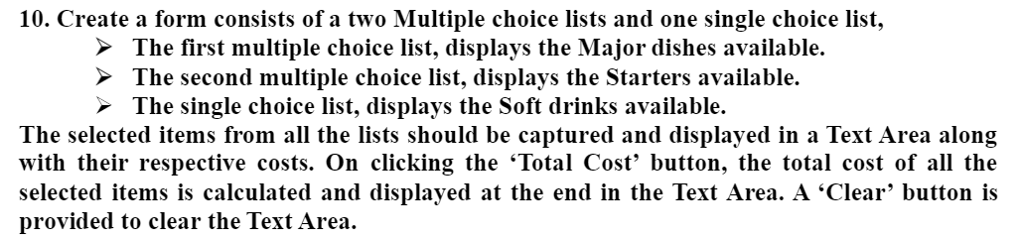

11)

 12)

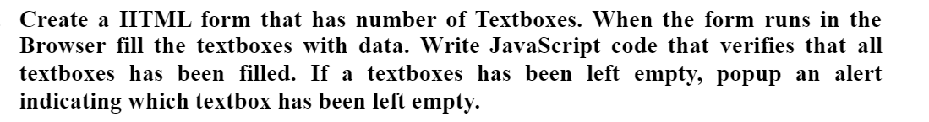 13)

14)

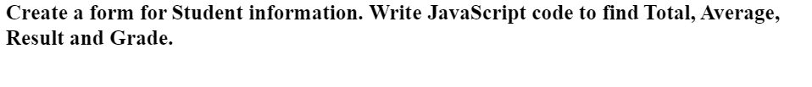 15)

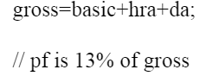16)